



**UNIVERSIDAD TECNOLÓGICA DE**

**SAN LUIS RIO COLORADO**

**PORTFOLIO**

**MTRA. CINTHYA RIVERA DIAZ**

**ALUMNO: VICTOR MANUEL GALVAN COVARRUBIAS**

San Luis Rio Colorado, Sonora March, 2021

Exercise 1

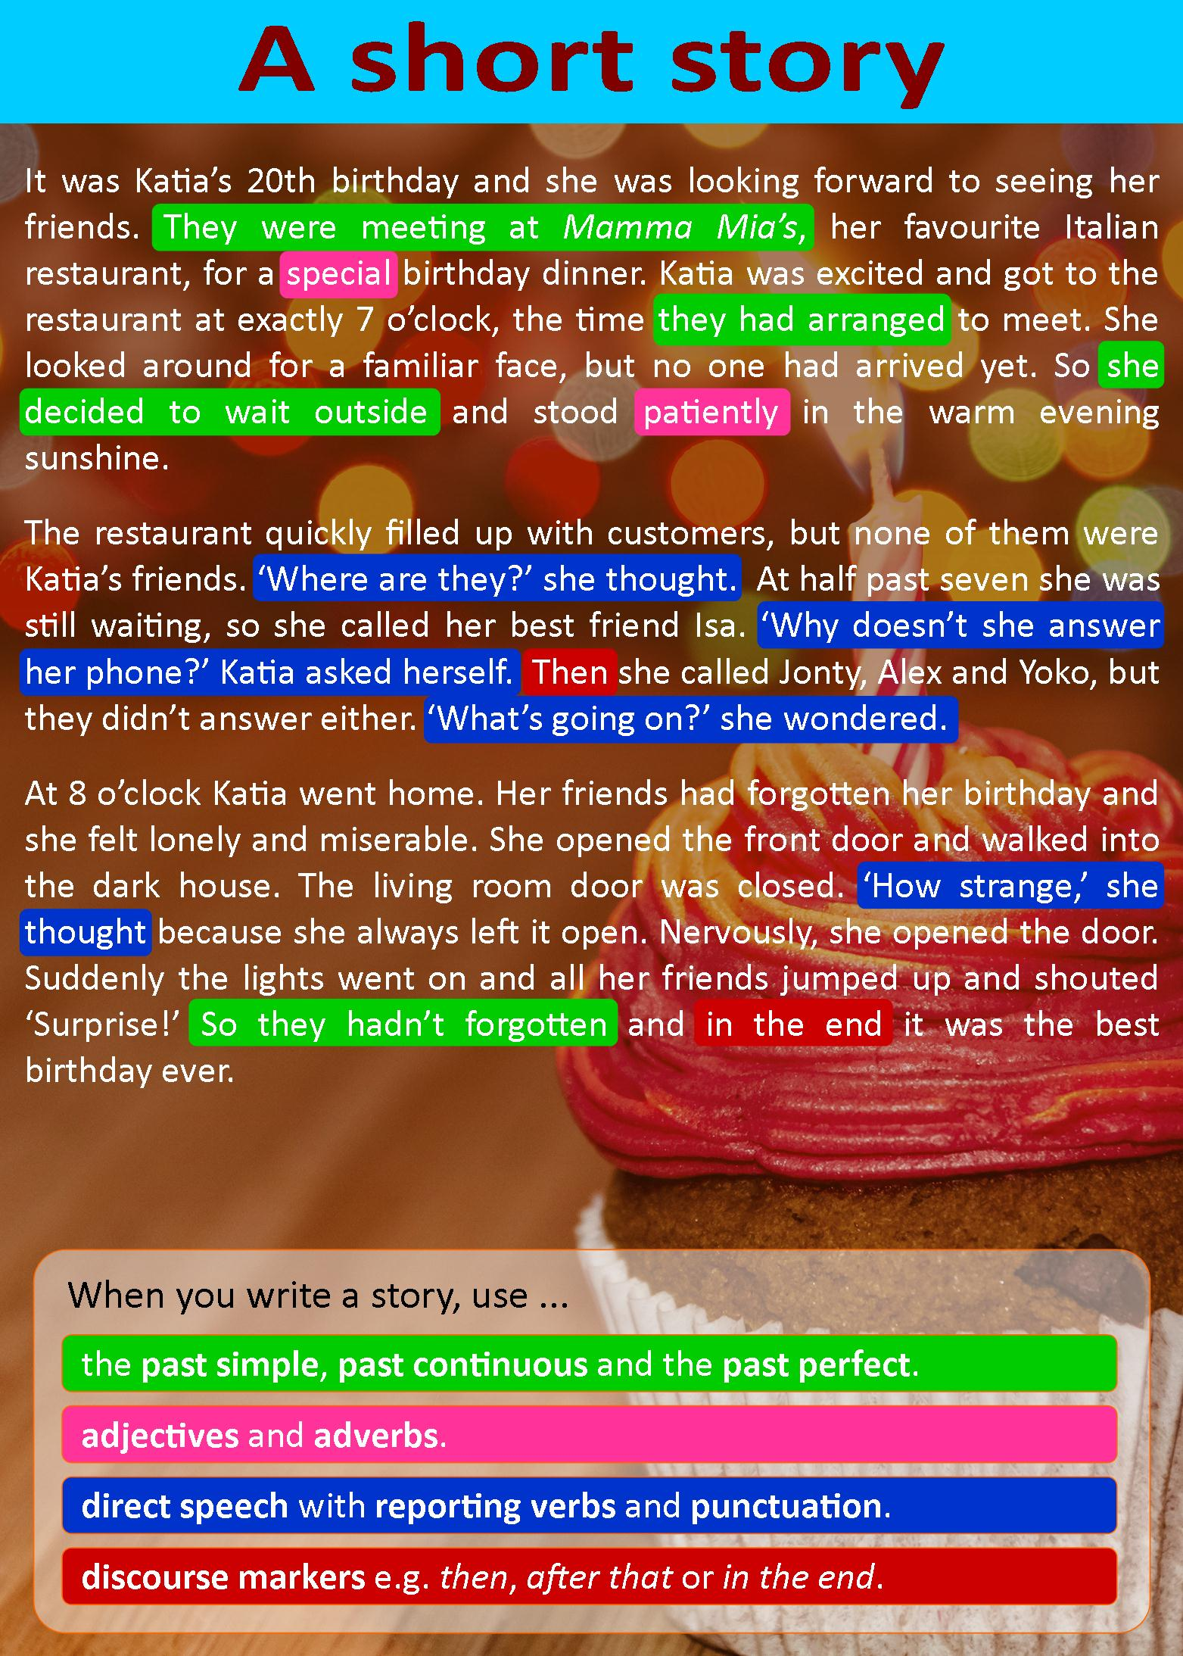

**A. Answer the following:**

1. Choose the best title for the story.

1. The accident
2. The surprise
3. My lucky day

2. Katia didn't want to celebrate her birthday.

* Principio del formulario
* True
* False

1. Final del formulario

3. Katia was the first person to arrive at the Italian restaurant.

* Principio del formulario
* True
* FalseFinal del formulario

4. Katia waited outside the restaurant for 30 minutes.

* Principio del formulario
* True
* FalseFinal del formulario

5. Jonty is Katia's closest friend.

* Principio del formulario
* True
* FalseFinal del formulario

6. Katia went home after waiting for her friends for an hour.

* Principio del formulario
* True
* FalseFinal del formulario

7. Katia's friends hadn't forgotten her birthday.

* Principio del formulario
* True
* False

**B. Match the sentences Match the sentences from the story to the correct part of the story.**

**Beginning:**

* They were meeting at Mamma Mia’s, her favorite Italian restaurant, for a special birthday dinner.

**Middle:**

* Then she called Jonty, Alex and Yoko, but they didn’t answer either. “What’s going on?” she said to herself.

**Ending:**

* Suddenly the lights went on and all her friends jumped up and shouted “Surprise!”

**Final line:**

* So they hadn’t forgotten and in the end it was the best birthday ever.

**C. Put the words in the correct group.**

enjoyable, quickly, happily, exciting, strange, freezing, awful, unexpectedly, slowly, quietly, fantastic, sadly, huge, unexpected, nervously, patiently

|  |  |
| --- | --- |
| **ADJECTIVES** | **ADVERBS** |
| enjoyable, exciting, strange, freezing, awful, fantastic, huge, unexpected | quickly, happily, unexpectedly, slowly, quietly, sadly, nervously, patiently |
|  |  |

Exercise 2

**FAMILY TREE**

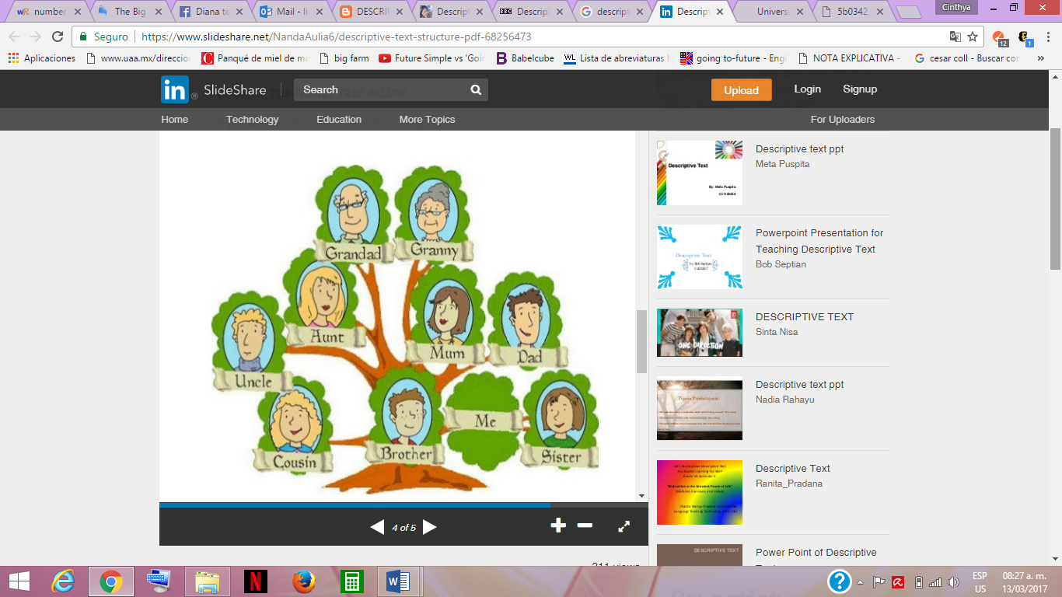

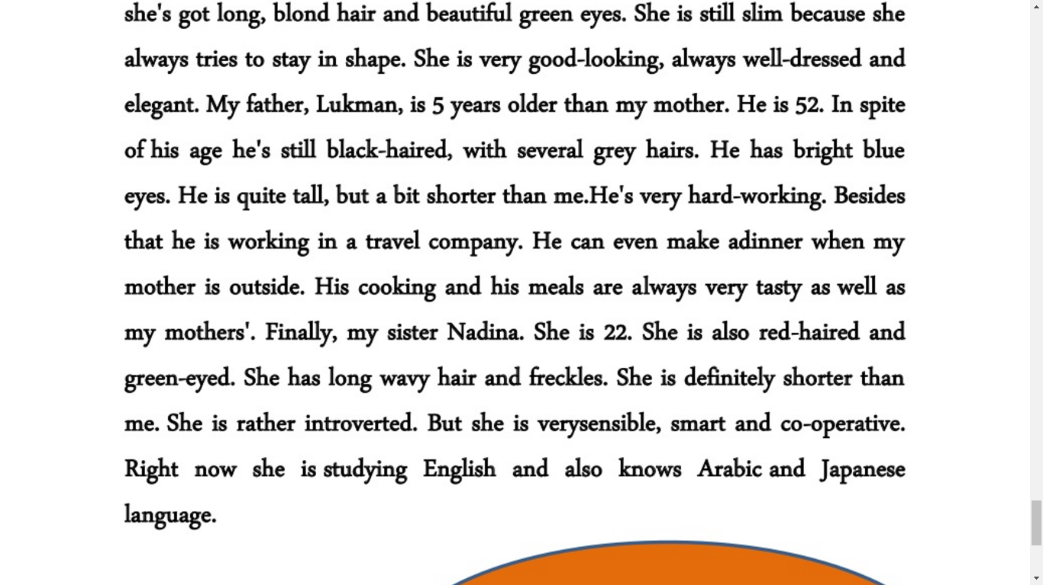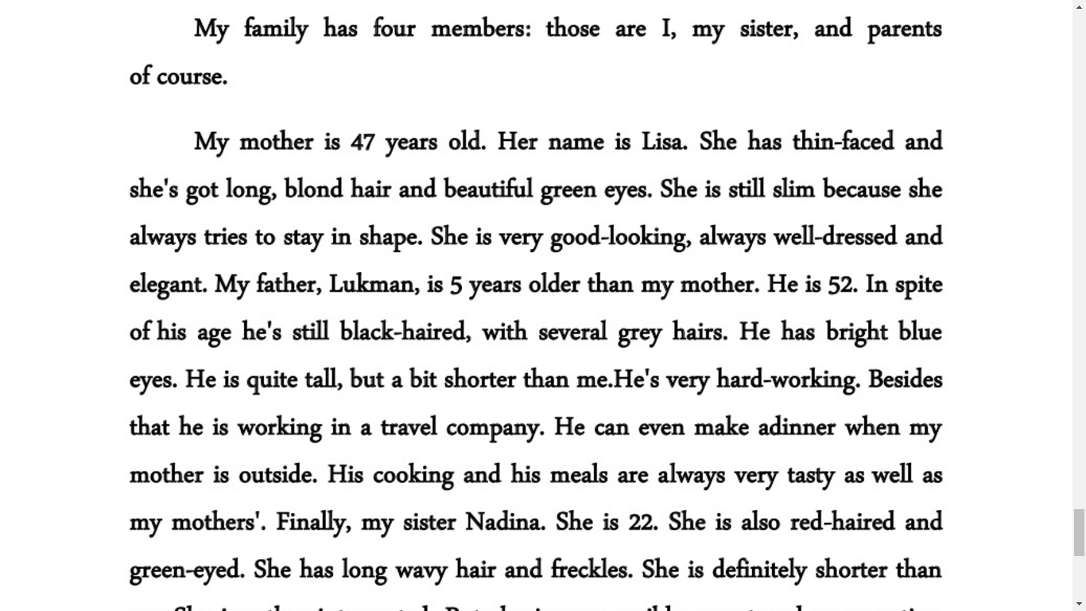

My family has five members: those are I, my sister, my brother, and parents of course.

My mother is 41 years old. Her name is Maria, she has thin-faced and she's got long dark hair and beautiful brown eyes. She is still slim because she always tries to stay in shape. She is very good-looking, always well-dressed and elegant. My father, Victor, is 6 years older than my mother. He is 47. he’s white-haired, with several grey hairs. He has brown eyes. He is short, shorter than me. He's very hard-working. Besides that, he is working in a food company. He makes dinner when my mother is outside. His cooking and his meals are always very tasty as well as my mothers'. My brother Martin is 24. He is also black-haired and brown-eyed. He has short hair. He is definitely taller than me. He is extroverted. He is strong, smart and co-operative. Right now He is not studying. Finally, my sister Daisy. She is 11. She is also black-haired and brown-eyed. She has long hair. She is definitely shorter than mesh is rather introverted. But she is very sensible and smart when she wants to. Right now she is studying Primary school.

Exercise 3

The fall of “The Flash”

Most of the people who started out watching "The Flash" didn't expect it to be such a great show. How the characters who participated in it were developed was the main thing in the series, the part of superpowers and fantasy went to the background, even being a means to exploit our favorite characters to the fullest. If we consult the ratings of seasons 1 and 2 in iMDB we can observe a high valuation in their chapters.

According to Jesse Schedeen (2015) “The Flash was unique in its first season in the sense that it never really needed to find itself or grow into something better. It simply started strong and continually got better over the course of seven months.”

but this sadly has waned over the years. The following seasons are not made with the commitment of all the people involved, which shows a tremendous decline in terms of show quality, everything that we loved in the first two seasons is now simply wasted to put our favorite characters in ridiculous situations instead of adding something to the plot built over the years.

According to David Hogan (2020) “S6 makes absolutely sure that a lot of a sense of fun the show used to have is dead and buried.”

Although many of us wish the creative decisions of the show would change. Unfortunately, that will not happen, it only remains for us to wait for the show that once excited us so much with the premises of a speedster to announce its last season or cancellation. It just remains for us to appreciate that first two seasons that made us experience so many emotions.

Exercise 4

I was 9 years old, it was a different day at school, I could feel it. When my brother and I left we observed that our parents had not come to pick us up but our uncle, we asked him where they were and why they had not come but he did not answer us.

When we got to our house all the lights were off and my father asked us not to make noise. We saw my mother lying on the bed as she was very tired of her. I approached with fear to ask her what she had. As she stands up and from her arms she shows us the little head of our sister who had already been born, she looked so small and fragile, since that day I knew that things would change because until that moment we had only been my brother and I . But now we all have a responsibility to care for and protect Daisy.

My family has grown over the years. Now Daisy is 11 years old and she is almost into high school. My brother is already an engineer and I am on my way to becoming one too. My parents take care of us. My perception of time has been altered considerably, now everything moves faster and you can feel the weeks fly by.